**Placement Data Analysis Using SQL**

**KPI’s**

1. **# Total Students**

SELECT DISTINCT

(COUNT(StudentID)) AS Total_Students

FROM

placementdata;

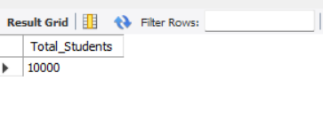

1. **# Highest Cgpa**

SELECT

MAX(cgpa) AS highest_cgpa

FROM

placementdata;

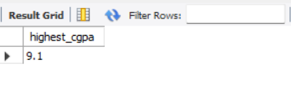

1. **# Total Students by different cgpa**

SELECT

COUNT(StudentID) AS Total_Students,

MAX(cgpa) AS highest_cgpa

FROM

placementdata

GROUP BY CGPA

ORDER BY cgpa ASC;

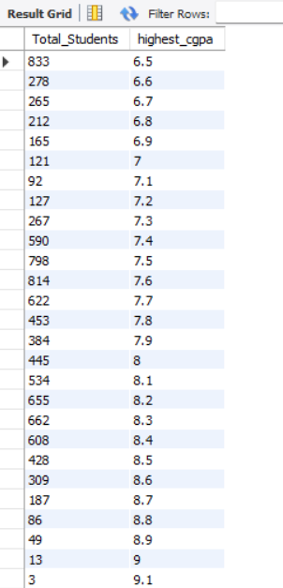

1. # Total Internships done by total students

SELECT

COUNT(studentid) AS Total_students, internships

FROM

placementdata

GROUP BY internships

ORDER BY internships ASC;

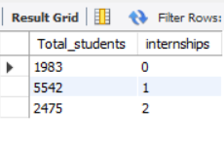

1. **#Total number of projects**

SELECT

projects,

COUNT(studentid) AS Total_Students,

SUM(projects) as Total_Projects

FROM

placementdata

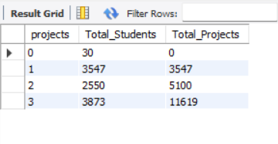GROUP BY projects order by projects asc;

1. **#Total Workshops**

SELECT

Workshops,

COUNT(studentid) AS Total_Students,

SUM(Workshops) as Total_Workshops

FROM

placementdata

GROUP BY Workshops order by Workshops asc;

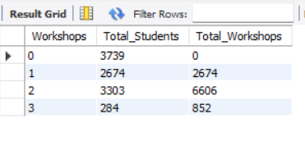

1. **# average SoftSkillsRating**

SELECT

ROUND(AVG(SoftSkillsRating), 2) as Average_Rating

FROM

placementdata;

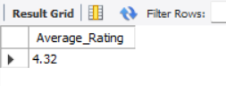

1. **#total students by scorewise**

SELECT

COUNT(studentid)as Total_Students,aptitudetestscore as Score

FROM

placementdata

GROUP BY aptitudetestscore

ORDER BY aptitudetestscore ASC;

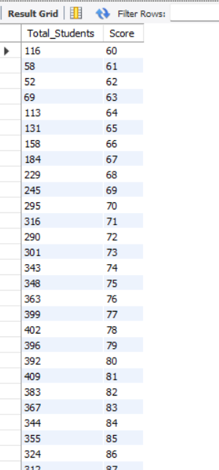

1. **#total students who are opted for training**

SELECT

PlacementTraining,count(StudentID) as Total_Students, round(avg(StudentID),2) as Average

FROM

placementdata

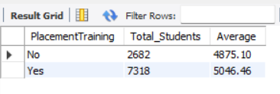GROUP BY PlacementTraining;

1. **#percentage of placed and not placed students**

SELECT

COUNT(studentid), PlacementStatus,round(count(StudentID)*100/10000,2) as Percentage

FROM

placementdata

GROUP BY PlacementStatus;

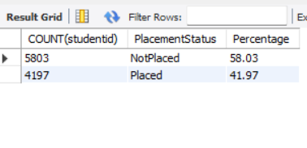

1. **# sum of Projects**

SELECT

SUM(projects) AS Total_projects

FROM

placementdata;

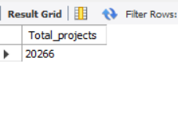

1. **# sum of Workshops**

SELECT

SUM(workshops) AS Total_projects

FROM

placementdata;

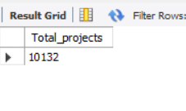

1. **# sum of Internships**

SELECT

SUM(Internships) AS Total_projects

FROM

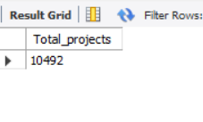 placementdata;